Investigation 1.5.1 Reactions of Four Isomers of Butanol

Submitted By: Kevin An, Austin Ho, Tony Nguyen, Genard Nonan, Santiago Valdes
Submitted To: Mr. Romano
Course Code: SCH4UP
Submitted On: Friday, November 11, 2016
Purpose:
Refer to page 64 of textbook “Nelson Chemistry 12”.

Materials:
Refer to page 64 of textbook “Nelson Chemistry 12”. Note that four test tubes were used instead of three, an eyedropper was not used, and 2-methylpropan-1-ol was also used.

Procedure:
Refer to page 64 of textbook “Nelson Chemistry 12”. Note that in step 2, a fourth test tube was used and filled with 2-methylpropan-1-ol. In step 3, drops of hydrochloric acid were added by the students, not the teacher.

Observations:

Table 1: Observations When Hydrochloric Acid was Mixed with the Isomers of Butanol
Isomer of Butanol | Observations
Butan-1-ol | No visible change
Butan-2-ol | Slight colour change to yellow
2-Methylpropan-1-ol | Miniscule colour change to yellow
2-Methylpropan-2-ol | Cloudy

Table 2: Observations When Potassium Permanganate was Mixed with the Isomers of Butanol
Isomer of Butanol | Observations
Butan-1-ol | Became slightly darker purple
Butan-2-ol | Colour change from purple to brown
2-Methylpropan-1-ol | Became slightly darker purple
2-Methylpropan-2-ol | No visible change

Discussion:

- The evidence of chemical reactions observed in this lab was the change of colour in the chemical solution and the formation of a precipitate in the solution.

Halogenation Reactions (HCl)
Butan-1-ol + HCl → 1-Chlorobutane + H₂O
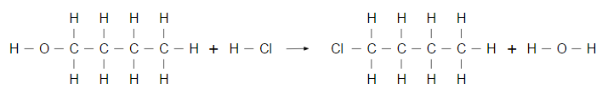

Butan-2-ol + HCl → 2-Chlorobutane + H₂O
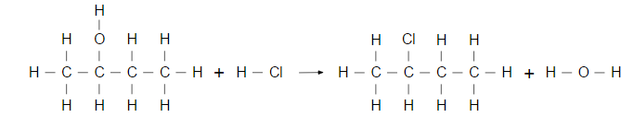

2-Methylpropan-1-ol + HCl → 1-Chloro-2-Methylpropane + H₂O
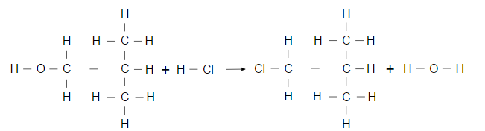

2-Methylpropan-2-ol + HCl → 2-Chloro-2-Methylpropane + H₂O
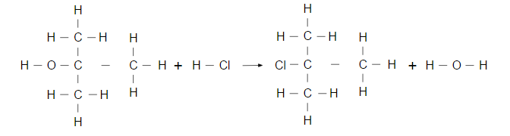

OXIDIZATION REACTION (KMnO₄)

Butan-1-ol + KMnO₄ → Butan-1-al + H₂O
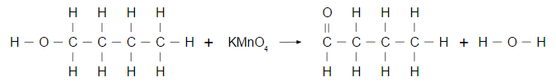

Butan-2-ol + KMnO₄ → Butan-2-one + H₂O
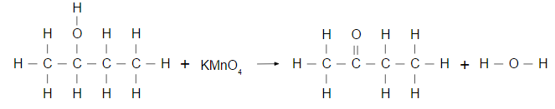

2-Methylpropan-1-ol + KMnO₄ → 2-Methylpropan-1-al + H₂O
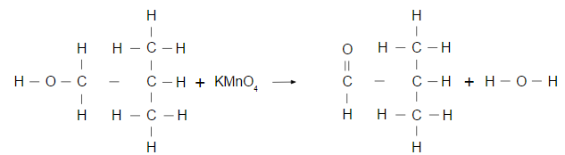

2-MethylPropan-2-ol + KMnO₄ → NR
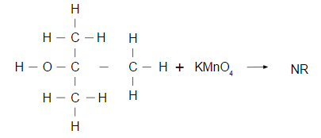

- Yes, the evidence collected in this lab allowed the purpose to be achieved. This is because we were able to test the reactions of one of each type of alcohol, 2 in the case of primary alcohols, and observed if there were any differences in the reaction of the alcohols with HCl, an acid, and KMnO₄, an oxidizing agent. The observations were recorded, in which the reactions of the different alcohols can be compared to see any similarities or differences between the reactions.

- The halogenation reactions of each alcohol were relatively the same. In each of the alcohols; primary, secondary, and tertiary, the OH bond on the organic molecule was replaced by a halogen bond. The resulting products were always an alkane that corresponds to the alcohol, with a chlorine branch attached, and H₂O. However, the rate in which this reaction occurred varied between the different alcohols. The tertiary alcohol reacted the fastest with a very noticeable precipitate, the secondary alcohol reacted slower with only a slight colour change, and the primary alcohols reacted the slowest with little to no colour change. In the controlled oxidation reactions, the primary and secondary alcohols reacted, while the tertiary alcohol did not. The primary alcohols produced an aldehyde, secondary produced a ketone, and tertiary did not produce anything due to the placement of the OH branch. The reaction of the secondary alcohol was the most noticeable with the purple solution turning brown, while the reactions of the primary alcohols were difficult to notice, since the solution only turned slightly darker purple from the original purple colour.

Conclusion:
In this lab, alcohols were reacted with oxidizing agents and acids to test the products. When primary alcohols were oxidized, an aldehyde was produced. When primary alcohols reacted with an acid, a halogenation reaction occurred at a very slow rate. When the secondary alcohol was oxidized, a ketone was produced. When a secondary alcohol reacted with an acid, a halogenation reaction occurred at a somewhat slow rate. When the tertiary alcohol was oxidized, no reaction occurred. When the tertiary alcohol reacted with an acid, a halogenation reaction occurred at a very fast rate. Some sources of error could be if the test tube was not cleaned well enough, and other contents were mixed it, which could result in a false conclusion since other chemicals could be potentially reacting. Another source of error could be if the test tubes were labelled incorrectly. This would, again, lead to incorrect conclusions, because the results would be swapped around. A last source of error could be the incorrect ratio amounts that was needed to for the full reaction to occur. For instance, there could have been not enough oxidizing agent or acids to cause a reaction in one of the alcohols. This would lead to another false conclusion because there would be no reaction, even though there should have been if the correct ratios were used.

References:
DiGiuseppe, Maurice. Chemistry 12. Toronto: Nelson Education, 2012. Print.

