Microbial Fuel Cell Technology

Submitted By: Austin Ho and Santiago Valdes
Submitted To: Mr. Romano
Course Code: SCH4UP
Submitted On: Monday, January 22, 2017

Abstract
This science fair is based on the research done by M.C. Potter on microbial fuel cells, and further goes into the details of what variables can be influenced to create the maximum output of energy. Using controlled variables such as different samples of dirt, and temperature allows for the manipulation of the final product. By collecting the data of multiple MFC’s and further analyzing and comparing the sets of data, an outlying conclusion arose from these findings. The soil from the creek was most effective due to it having the best organic molecules. Additives such as coconut water increases the production of power, acting almost like a catalyst for the harvested bacteria from the soil, while other additive such as paper seems to have little to no effect. Lastly, temperature has a great impact on the power voltage and current of the MFC, as it reacts similarly to the addition of coconut water. The increase in temperature allows the bacteria to work at optimal efficiency, while the decrease in temperature reduces the production of bacteria. For Microbial Fuel Cells to be working at optimal performance, three variables must be properly manipulated; temperature, soil samples, and additives. Using these variables, the efficiency of Microbial Fuel Cells can be increased dramatically.

Introduction and History
The idea of the microbial fuel cell was first conceived by professor M. C. Potter, a botanist from the University of Durham in 1911. He was able to create a primitive MFC using E. Coli in 1911 that was able to produce electricity. In 1931, Barnet Cohen used a number of half MFCs, which he connected in series to produce over 35 V with a current of 2 milliamps. Until the 1970’s, the working of a MFC were still not known. However, the idea was studied by Robin M. Allen and H. Peter Bennetto. Bennetto became one of the leading experts on MFC’s and helped identify how a MFC worked and how it could be used in developing countries for electricity. It was first found that electrogenic bacteria required a mediator to collect the electrons it produced and deposit it to the anode. These mediators were toxic and expensive, which made MFC technology unappealing. However, it was found that some bacteria can deposit these electrons through nanowires, which are organic appendages that mimic metals, and through direct cell wall contact. Common soil contains a variety of bacteria, one of which is the Shewanella genus. This species can produce electricity from anaerobic cellular respiration and uses nanowires to transfer electricity to the anodes of an MFC. These cells can also be used in hydrogen production, wastewater treatment, and desalination of salt water. It has been found that MFC technology can be more than 50% energy efficient, and could produce hydrogen 8 times more than hydrogen technology used today.

Purpose/Hypothesis
The purpose of our science fair project is to test the following variables to see if the output in energy is affected. These variables are temperature, different soil samples as well as additives. After conducting research, we believe that the results of the project will display that heat is favorable for the production of bacteria meaning that more microwatts will be produced as a response. As for soil sample we believe that the soil sample that contains the most amount of bacteria and organic material will be the most favourable. The additives are paper strips to increase the presence of organic molecules which an electrolyte will be added to examine if it affects power generation. We will also be comparing the results of commercial MFC’s to a DIY model to identify similarities and differences.

Methods and Materials
Commercial MFC Kit:
Mudwatt Science Fair Pack containing:
- 6 graphite felt discs and wires
- 3 Blinker Boards
- 3 Capacitors
- 3 LEDs
- Gloves
- 3 Vessels/Containers
- Multimeter
Soil
- 6-8 Handfuls of Soil from a Garden
- 3-4 Handfuls of Soil from a Creek
- Handful of Paper Strips
- Water
- Coconut Water
DIY Microbial Fuel Cell
- 2 (4 Liters Containers with lids)
- 10 cm long (6 inch diameter PVC Pipe)
- 2 Threaded PVC connectors and the appropriate fittings
- 2 Metallic Circular Clamps
- 1 Cotton t-shirt
- 1 Aluminum Scrubber
- 2 Alligator clip wires
- Glue Gun
- Glue Sticks
- Rubber Bands
- Plastic Bag
- Aquarium Pump with hose
- 3.5 Liters of Mud
- ⅓ Cup of Salt
- 1 Small Pot
- Spoon
- 1 Voltmeter
- 1 Container of Silicon
- Drill/Welding Iron

Procedure
Commercial Microbial Fuel Cell
- Follow instructions in the instruction manual which are:
- Insert bare end of wires into graphite discs (electrodes).
- Fill the container with 1cm of mud.
- Place the anode onto the mud.
- Cover the anode with at least 5cm of mud on top.
- Place the cathode on top of mud.
- Pass wires through opening in lid and connect to the blinker board.
- Connect capacitor and LED to blinker board.
DIY Microbial Fuel Cell
- Collect dirt from a nearby creek. Enough to fill a 4 Liter container.
- Depending on the condition of the dirt add water to moisten, or if too liquidy, let it stand for minutes. This allows the dirt to sink to the bottom and the extra water to accumulate to the top. Pour out the water. Use these methods to make the condition of the dirt similar to that of mud.
- Carefully cut a hole on the side of both containers. Makes sure it is the right size to glue on the two fittings.
- Use the silicon to hold the fittings in place on either side of the containers. The silicon also prevents any leaks, since it is waterproof once it dries.
- Get the 10 cm PVC pipe and fit the 2 threaded connectors on either side. Be sure to add some silicon along the rim of where the connectors meet the pipe, to allow for minimal leaking of water. Let it dry.
- Cut the plastic bag into two pieces that are large enough to cover each hole. Use a rubber band to keep it in place around the PVC fitting. This blocks the fitting, allowing the
- Pour in 3.5 L of mud into one container and 3.5L of water into the other container.
- Using a drill or a welding iron, poke one hole on the lid that belongs to the container filled with mud.Create this hole right in the middle. Make sure the the size of the hole is large enough to fit your Alligator wire through it.
- Repeat the previous for the lid of the water container. Add two more holes on either side of the hole at the center for ventilation. These extra two holes don't have to be as large in size as the hole in the middle.
- Break the Aluminum scrub into two somewhat equal in proportions.
- Connect the one end of a Alligator wire to the Aluminum scrub, and leave the other side empty. Do the same for both wires, each on a separate piece of the Aluminum scrubber.
- Place one piece of the Aluminum scrub into the middle of each container. Push the empty end of the Alligator wire through the hole created in step 8 and 9.
- Feed the air pumps hose through the cap of the water container. It goes through the same hole as the Alligator wires.Make sure the hose is relatively low in the water, so that it can be oxygenated thoroughly.
- Moving on to the salt bridge. Roll your t-shirt just thick enough to fit into the PVC pipe you created. Wrap rubber bands around the t-shirt to keep it from unrolling.
- Heat water to about lukewarm (40℃). Once the temperature has reached lukewarm, add ⅓ cup of salt to the mixture and stir.
- Add the t-shirt while the water is still foggy from salt, and fully submerge it in the water. Continue to stir the mixture with the t-shirt inside.
- Once the t-shirt is soaked in the water, remove it carefully, and begin to squeeze it into the PVC salt bridge. Make sure that the t-shirt is equally distributed on both sides.
- Once the t-shirt is inside the PVC pipe, begin to screw the threaded ends onto the PVC fittings. Make sure the PVC pipe is screwed in tightly, to ensure minimal leakage.
- Remove the plastic coverings on the inside of each containers.
- Use glue gun to seal the spaces around the wires on each lid. Make sure to leave the vents open.
- Your Microbial Fuel Cell is ready for testing. To get accurate results test multiple times for more precision.
Temperature Testing
- Place the MFC in a container that is shorter than the MFC. Fill the container with hot water and wait until the two have reached a temperature equilibrium by measuring the temperature of both items with a thermometer.
- Measure the current and voltage using the multimeter. Calculate the power by multiplying these two values or use the Mudwatt app to measure power.
- Repeat with different water temperatures until satisfaction of measured results.

Results

Figure 1: Power produced by commercial MFC’s
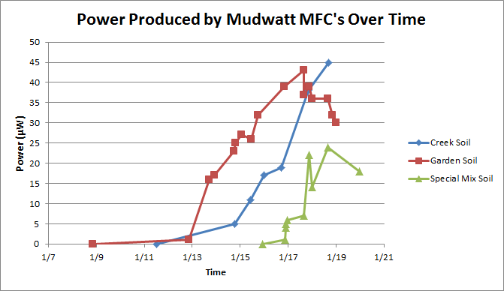

Figure 2: Power produced by DIY MFC
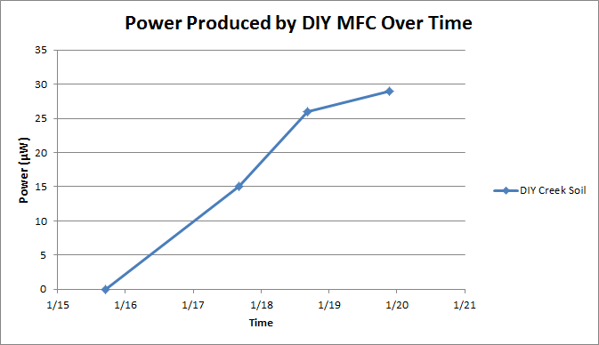

Figure 3: The effect of temperature on power production
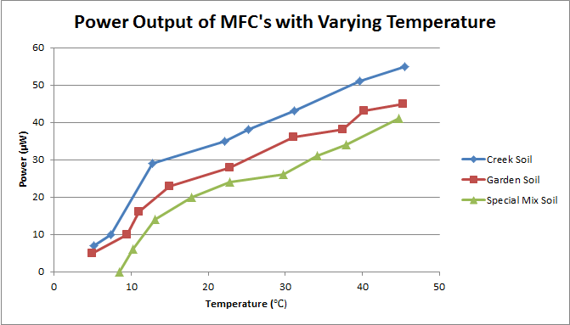

Figure 4: The effect of temperature on voltage produced
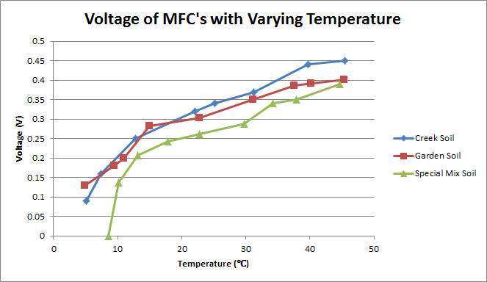

Figure 5: The effect of temperature on current produced
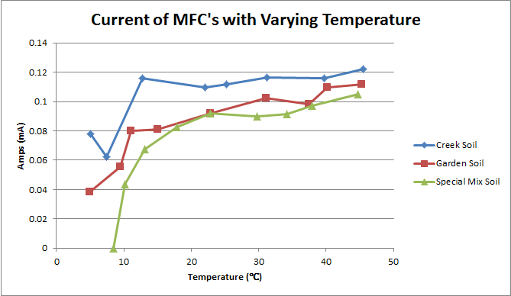

Discussion/Analysis
Examining Figure 1, one would notice that the three different soil types have vastly different graphs. The garden soil initially took 4 days to start producing power, the creek soil took three days to start producing power, and the special mix soil took only 22 hours to start producing power. A fourth soil type, potting soil, was initially tested as well, however this soil could not produce any power after 4 days, with a maximum of 0.001V. This is because while potting soil is rich in organic material for the microbacteria to consume, it is made of little to no soil. This means that no electrogenic bacteria is present in the soil, yielding no power output. The creek soil MFC started producing power in 3 days, with an approximately steady and constant increase since it has been active. This shows that there is lots of organic material for the bacteria to eat, as well as a large amount of bacteria present in the soil. The garden soil MFC started producing power within 4 days. However, unlike the creek soil MFC, the power output was initially very high, but after approximately a week started losing power until is remained around 30 microwatts.This shows that the garden soil may have started off with less bacteria in the soil than the creek soil, and that there is less organic molecules to be found in the garden soil since the voltage and bacteria population began dropping. The special mix MFC took less than one day to produce power, and initially increased rapidly before, like the garden soil MFC, it slowed down and has somewhat decreased. This is because the mixed soil is formed from the same soil as the garden soil, which means that there is not as much organic molecules as the creek soil. Paper strips were added to this MFC to increase the amount of organic molecules, but does not seem to have worked. This is most likely because paper is treated with chemicals during production, which may hinder the biological processes needed to break it down by the bacteria. However, the addition of coconut water appears to have had a positive effect on the fuel cell. The increased amount of electrolytes in the soil allowed the MFC to produce power at a faster rate than the other MFCs. This is because in the other MFCs, the humic acid in the soil forms the electrolytes which allow the H⁺ ions to travel through to complete the circuit, acting as a salt bridge. When coconut water was added, it increased the number of electrolytes present in the soil, allowing H⁺ ions to travel through the soil more easily and complete the circuit. Examining Figure 2, the DIY MFC was able to produce power in two days and has been steadily increasing. This is because it uses creek soil, which was found to have more organic molecules for the bacteria than other soils. This MFC also contains more soil and a larger anode, allowing for more bacteria to deposit electrons onto the circuit.

Examining Figures 3, 4, and 5, one would notice a trend coming from these graphs. In Figure 3, all three soils exhibit the same reaction to temperature. As the temperature increases, the power production increases, and as the temperature decreases, the power production also decreases. An interesting note is that for the most part the graphs appear linear, however, when it reaches colder temperatures the power production drops more rapidly. Looking at Figure 4, it is noticed that the voltage produced follows a similar trend. And increase in temperature results in an increase in voltage, and vice versa. This graph also exhibits the property that at colder temperatures the graph decreases more rapidly. Examining Figure 5 results in the same conclusion as the other graphs. The current produced by the bacteria is affected by temperature as well. Increasing temperature increases voltage, and vice versa. An interesting point in this graph is at the coldest temperature for creek soil, which actually increased the current. This is most likely due to errors discussed in the conclusion of this lab and should be ignored. The rapidly changing temperature conditions of this test appears to have reduced the bacteria population in all of the MFC’s, resulting in lower power output afterwards which shows that fluctuating temperatures can easily destroy the bacteria population and render the MFC useless.

Conclusion
Overall, this experiment yielded a variety of surprising results. It was found that creek soil had the most organic molecules and initial bacteria than garden or potting soil, resulting in a steadily increasing power graph over time. Potting soil had plenty of organic molecules, however, contained almost no actual soil which yielded no power produced. Garden soil had a decent amount of organic molecules and bacteria inside it, however, there does not seem to be enough organic matter to feed all of the bacteria growing inside the cell, resulting in a decreasing power production and bacteria population until a stable level was reached. Adding shredded paper strips appeared to not increase power production in any way, even though it is an organic molecule, which is due to the chemical process of paper production. Coconut water increased the rate of power production in MFC’s since its added electrolytes allowed H⁺ ions to travel through soil easier and complete the circuit. It was found that temperature affects the bacteria’s power, voltage, and current production as well. An increase in temperature would result in an increase in power, voltage and current while a decreasing temperature would result in a decrease in power, voltage, and current. It was also seen that this followed a mainly linear pattern with the exception of the colder temperatures, which decreased electricity generation more quickly the colder it got. It was also observed that the rapidly fluctuating temperatures killed off some of the bacteria population, since after the tests the power production was lower than it was initially.

There were many sources of error that could have occurred during the course of this experiment. One source of error is if the anode was aerated. This would result in the bacteria undergoing aerobic respiration and producing water instead of H⁺ ions and e⁻ particles during anaerobic respiration. Another source of error is if the multimeter was not connected properly. The multimeter should be connected in parallel for measuring voltage and in series for measuring current. An error that could have also occurred during this lab was if the exposed ends of the wires rusted. This would prevent electrons from moving through the wires and decrease current production. Another source of error would be measuring the electricity of the MFC when the temperature of the heating/cooling element is not equal to the soil temperature. This would result in values that are skewed and would prevent accurate data from being recorded.

References

Illumin - Microbial Fuel Cells: Generating Power from Waste. (n.d.). Retrieved January 20, 2017, from http://illumin.usc.edu/134/microbial-fuel-cells-generating-power-from-waste/

Jurtshuk, P., & J. (1996, January 01). Bacterial Metabolism. Retrieved January 20, 2017, from https://www.ncbi.nlm.nih.gov/books/NBK7919/#_A392_

Magical Microbes. (n.d.). Retrieved January 20, 2017, from https://www.magicalmicrobes.com/

Microbial fuel cell as new technology for bioelectricity generation: A review. (n.d.). Retrieved January 20, 2017, from http://www.sciencedirect.com/science/article/pii/S1110016815000484

M. (n.d.). Mudwatt Guide to Discovering Mud Power! Retrieved January 20, 2017, from https://s3.amazonaws.com/cdn.teachersource.com/downloads/lesson_pdf/MudWatt_Educational_and_Instructional_Booklet.pdf

M. (n.d.). Mudwatt NCSS Teacher's Guide. Retrieved January 20, 2017, from https://s3.amazonaws.com/cdn.teachersource.com/downloads/lesson_pdf/MudWatt_MainModule.pdf

Robinson, P. (2016, May 18). What is a Microbial Fuel Cell. Retrieved January 20, 2017, from https://protonex.com/blog/what-is-a-microbial-fuel-cell/

Appendices

Table 1: Power Output of Garden MFC
Date | Power(Microwatts)
1/8/2017 20:45 | 0
1/12/2017 20:36 | 1
1/13/2017 17:14 | 16
1/13/2017 22:06 | 17
1/14/2017 17:56 | 23
1/14/2017 19:27 | 25
1/15/2017 1:23 | 27
1/15/2017 10:53 | 26
1/15/2017 17:31 | 32
1/16/2017 20:13 | 39
1/17/2017 15:41 | 43
1/17/2017 15:44 | 37
1/17/2017 20:51 | 39
1/18/2017 0:09 | 36
1/18/2017 15:53 | 36
1/18/2017 20:14 | 32
1/18/2017 23:58 | 30

Table 2: Power Output of Creek MFC
Date | Power(Microwatts)
1/11/2017 12:08 | 0
1/14/2017 18:44 | 5
1/15/2017 10:38 | 11
1/15/2017 23:40 | 17
1/16/2017 17:15 | 19
1/17/2017 20:38 | 38
1/18/2017 16:36 | 45

Table 3: Power Output of Special Mix MFC
Date | Microwatts
1/15/2017 22:35 | 0
1/16/2017 20:40 | 1
1/16/2017 21:39 | 4
1/16/2017 21:58 | 5
1/16/2017 23:00 | 6
1/17/2017 15:43 | 7
1/17/2017 20:47 | 22
1/18/2017 0:11 | 14
1/18/2017 15:32 | 24
1/19/2017 23:05 | 18

Table 4: Power Output of DIY MFC
Date | Microwatts
1/15/2017 | 0
1/17/2017 16:14 | 15
1/18/2017 16:25 | 26
1/19/2017 21:19 | 29

Table 5: Electrical Properties of Garden MFC with Varying Temperature
Temperature(^{O}C) | Power(Microwatts) | Voltage(V) | Current(Milliamps)
4.9 | 5 | 0.13 | 0.038462
9.5 | 10 | 0.18 | 0.055556
11 | 16 | 0.2 | 0.08
15 | 23 | 0.283 | 0.081272
22.8 | 28 | 0.304 | 0.092105
31.1 | 36 | 0.351 | 0.102564
37.5 | 38 | 0.387 | 0.098191
40.2 | 43 | 0.392 | 0.109694
45.3 | 45 | 0.402 | 0.11194

Table 6: Electrical Properties of Creek MFC with Varying Temperature
Temperature(^{O}C) | Power(Microwatts) | Voltage(V) | Current(Milliamps)
5.1 | 7 | 0.09 | 0.077778
7.4 | 10 | 0.16 | 0.0625
12.8 | 29 | 0.25 | 0.116
22.1 | 35 | 0.32 | 0.109375
25.2 | 38 | 0.34 | 0.111765
31.2 | 43 | 0.37 | 0.116216
39.7 | 51 | 0.44 | 0.115909
45.5 | 55 | 0.45 | 0.122222

Table 7: Electrical Properties of Special Mix MFC with Varying Temperature
Temperature(^{O}C) | Power(Microwatts) | Voltage(V) | Current(Milliamps)
8.5 | 0 | 0 | 0
10.2 | 6 | 0.137 | 0.043796
13.1 | 14 | 0.207 | 0.067633
17.8 | 20 | 0.242 | 0.082645
22.8 | 24 | 0.261 | 0.091954
29.8 | 26 | 0.289 | 0.089965
34.2 | 31 | 0.34 | 0.091176
37.9 | 34 | 0.35 | 0.097143
44.7 | 41 | 0.39 | 0.105128

