Investigation 1.6.3 Making Soap

Submitted By: Tony Nguyen, Genard Nonan, Santiago Valdes, Chris Power
Submitted To: Mr. Romano
Course Code: SCH4UP
Submitted On: Friday, November 30, 2016

Purpose:
Refer to page 67 of textbook “Nelson Chemistry 12”.

Materials:
Refer to page 67-68 of textbook “Nelson Chemistry 12”.

Modifications
- No Wax Pencil was used
- No Forceps were used
- No Heat Resistant Mat
- No Perfume, instead we created our own esters.

Procedure:
Refer to page 68 of textbook “Nelson Chemistry 12”.

Observations:
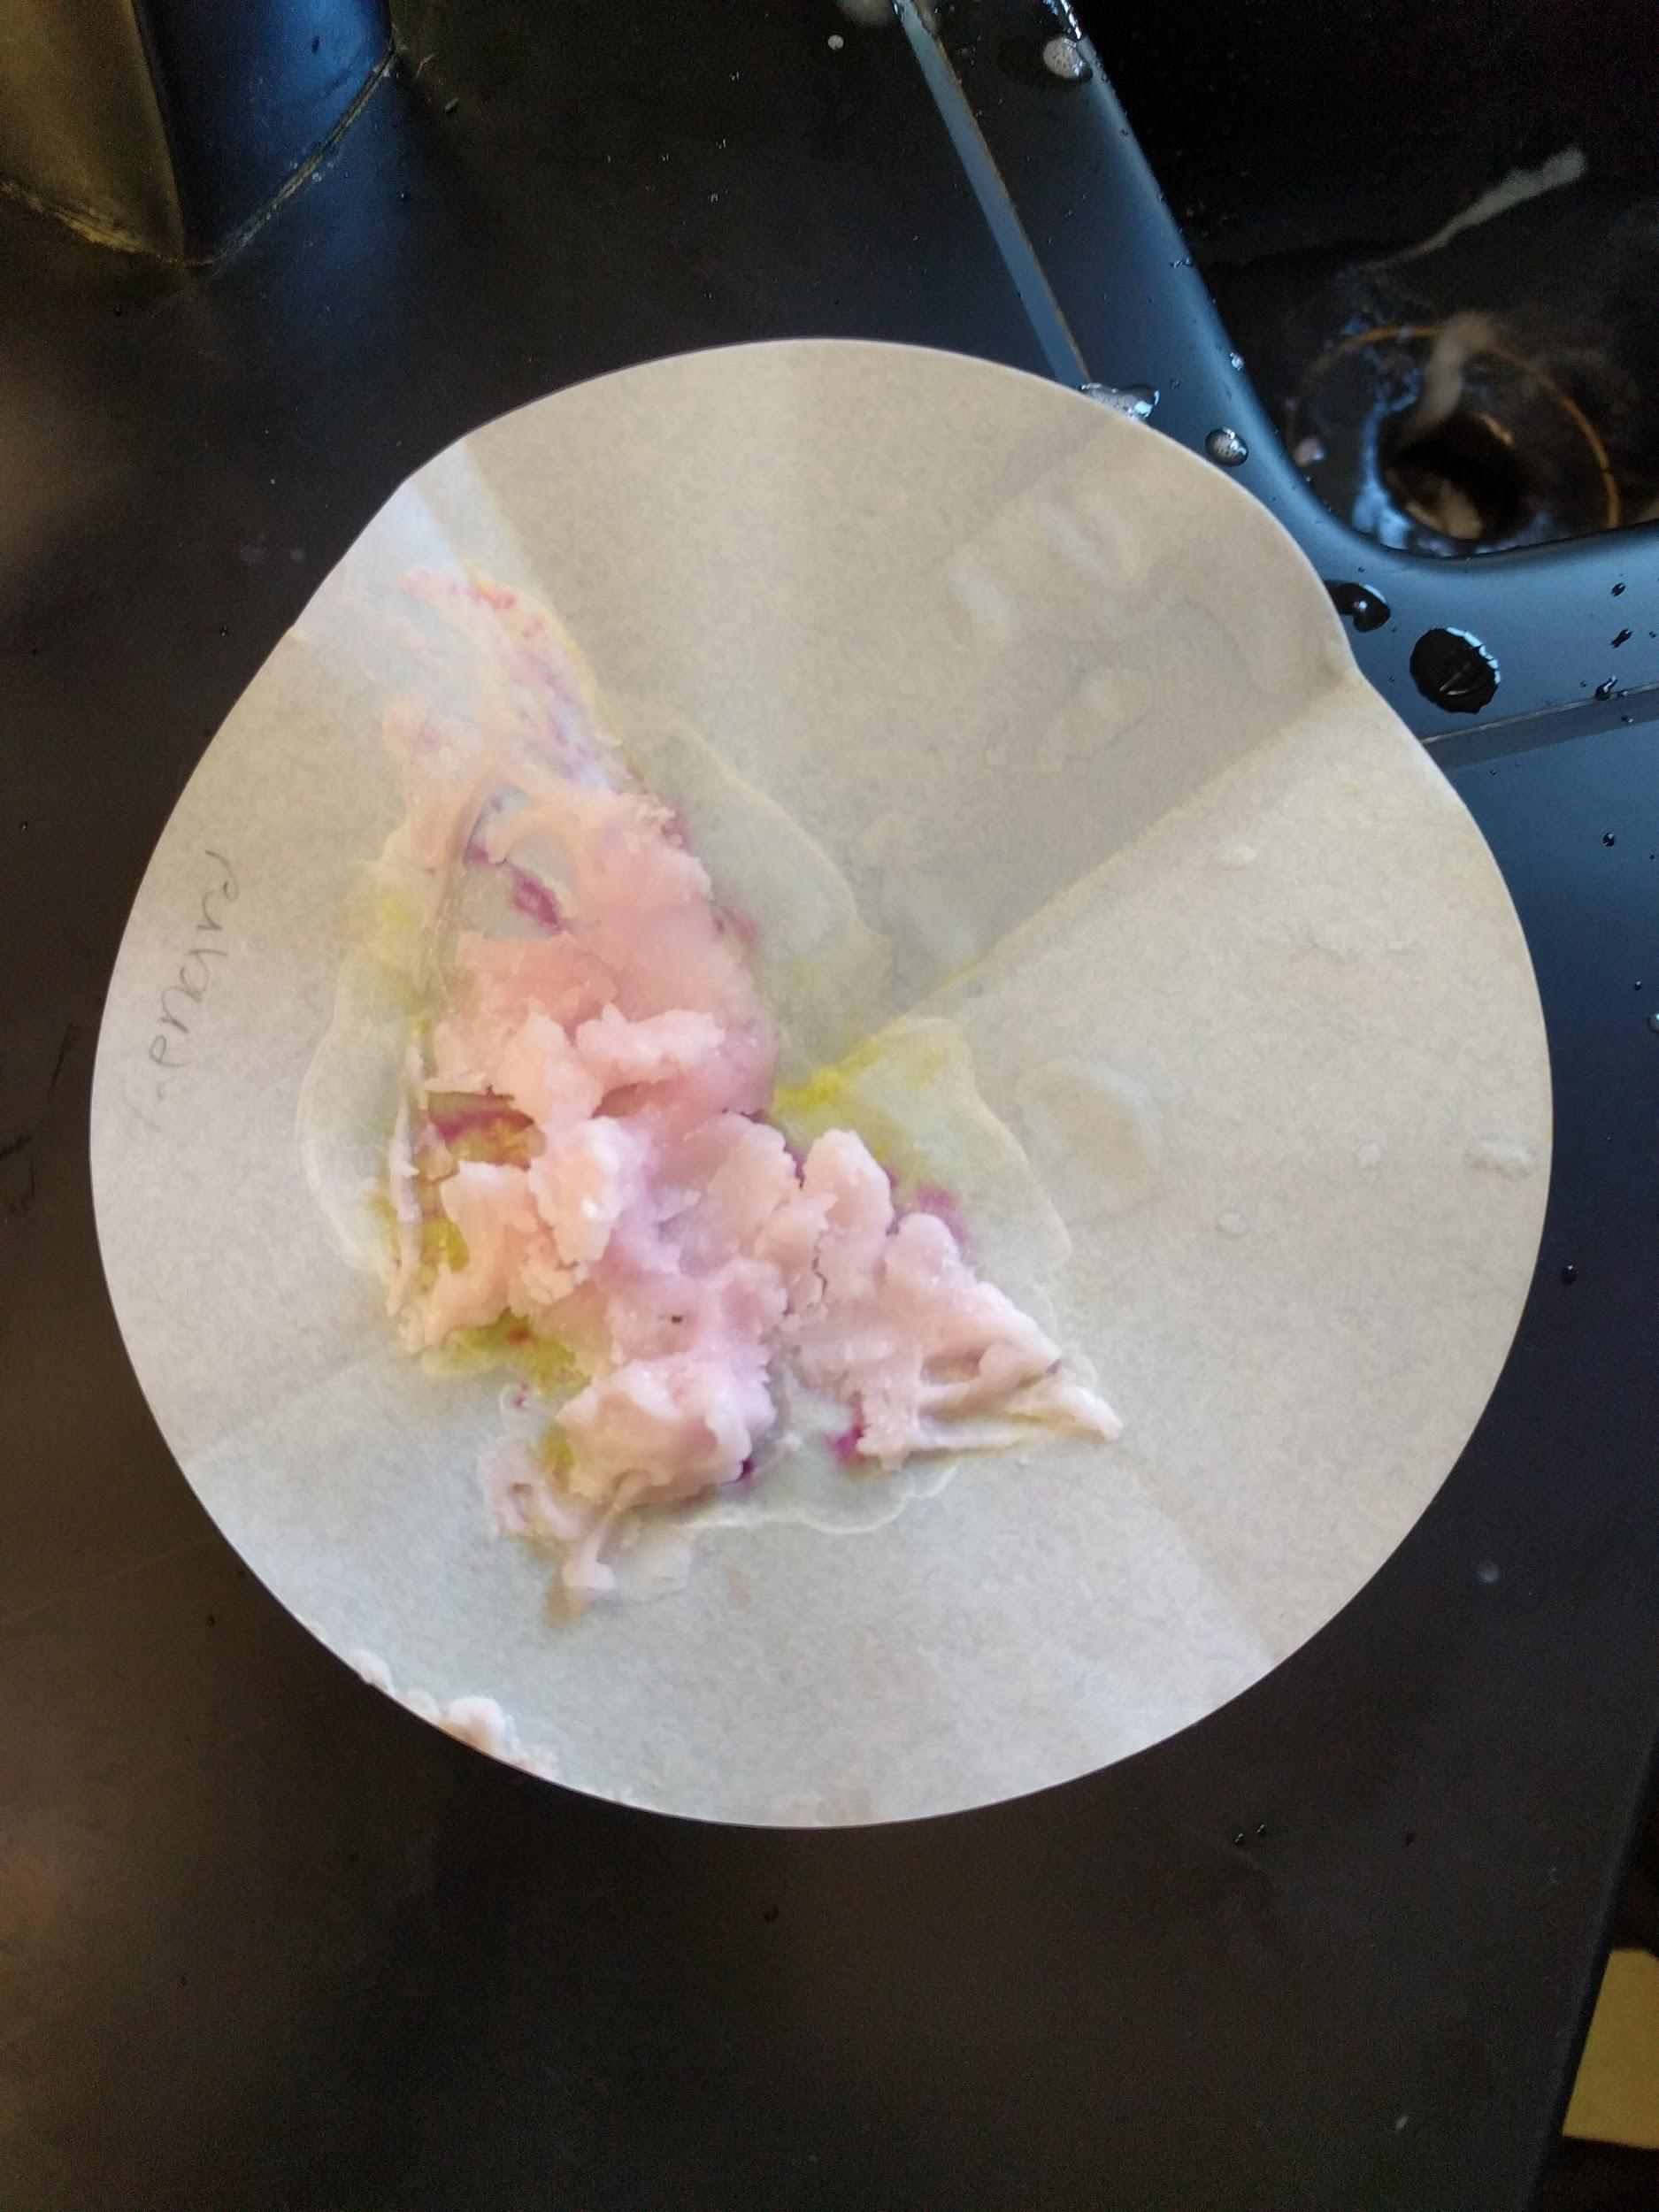
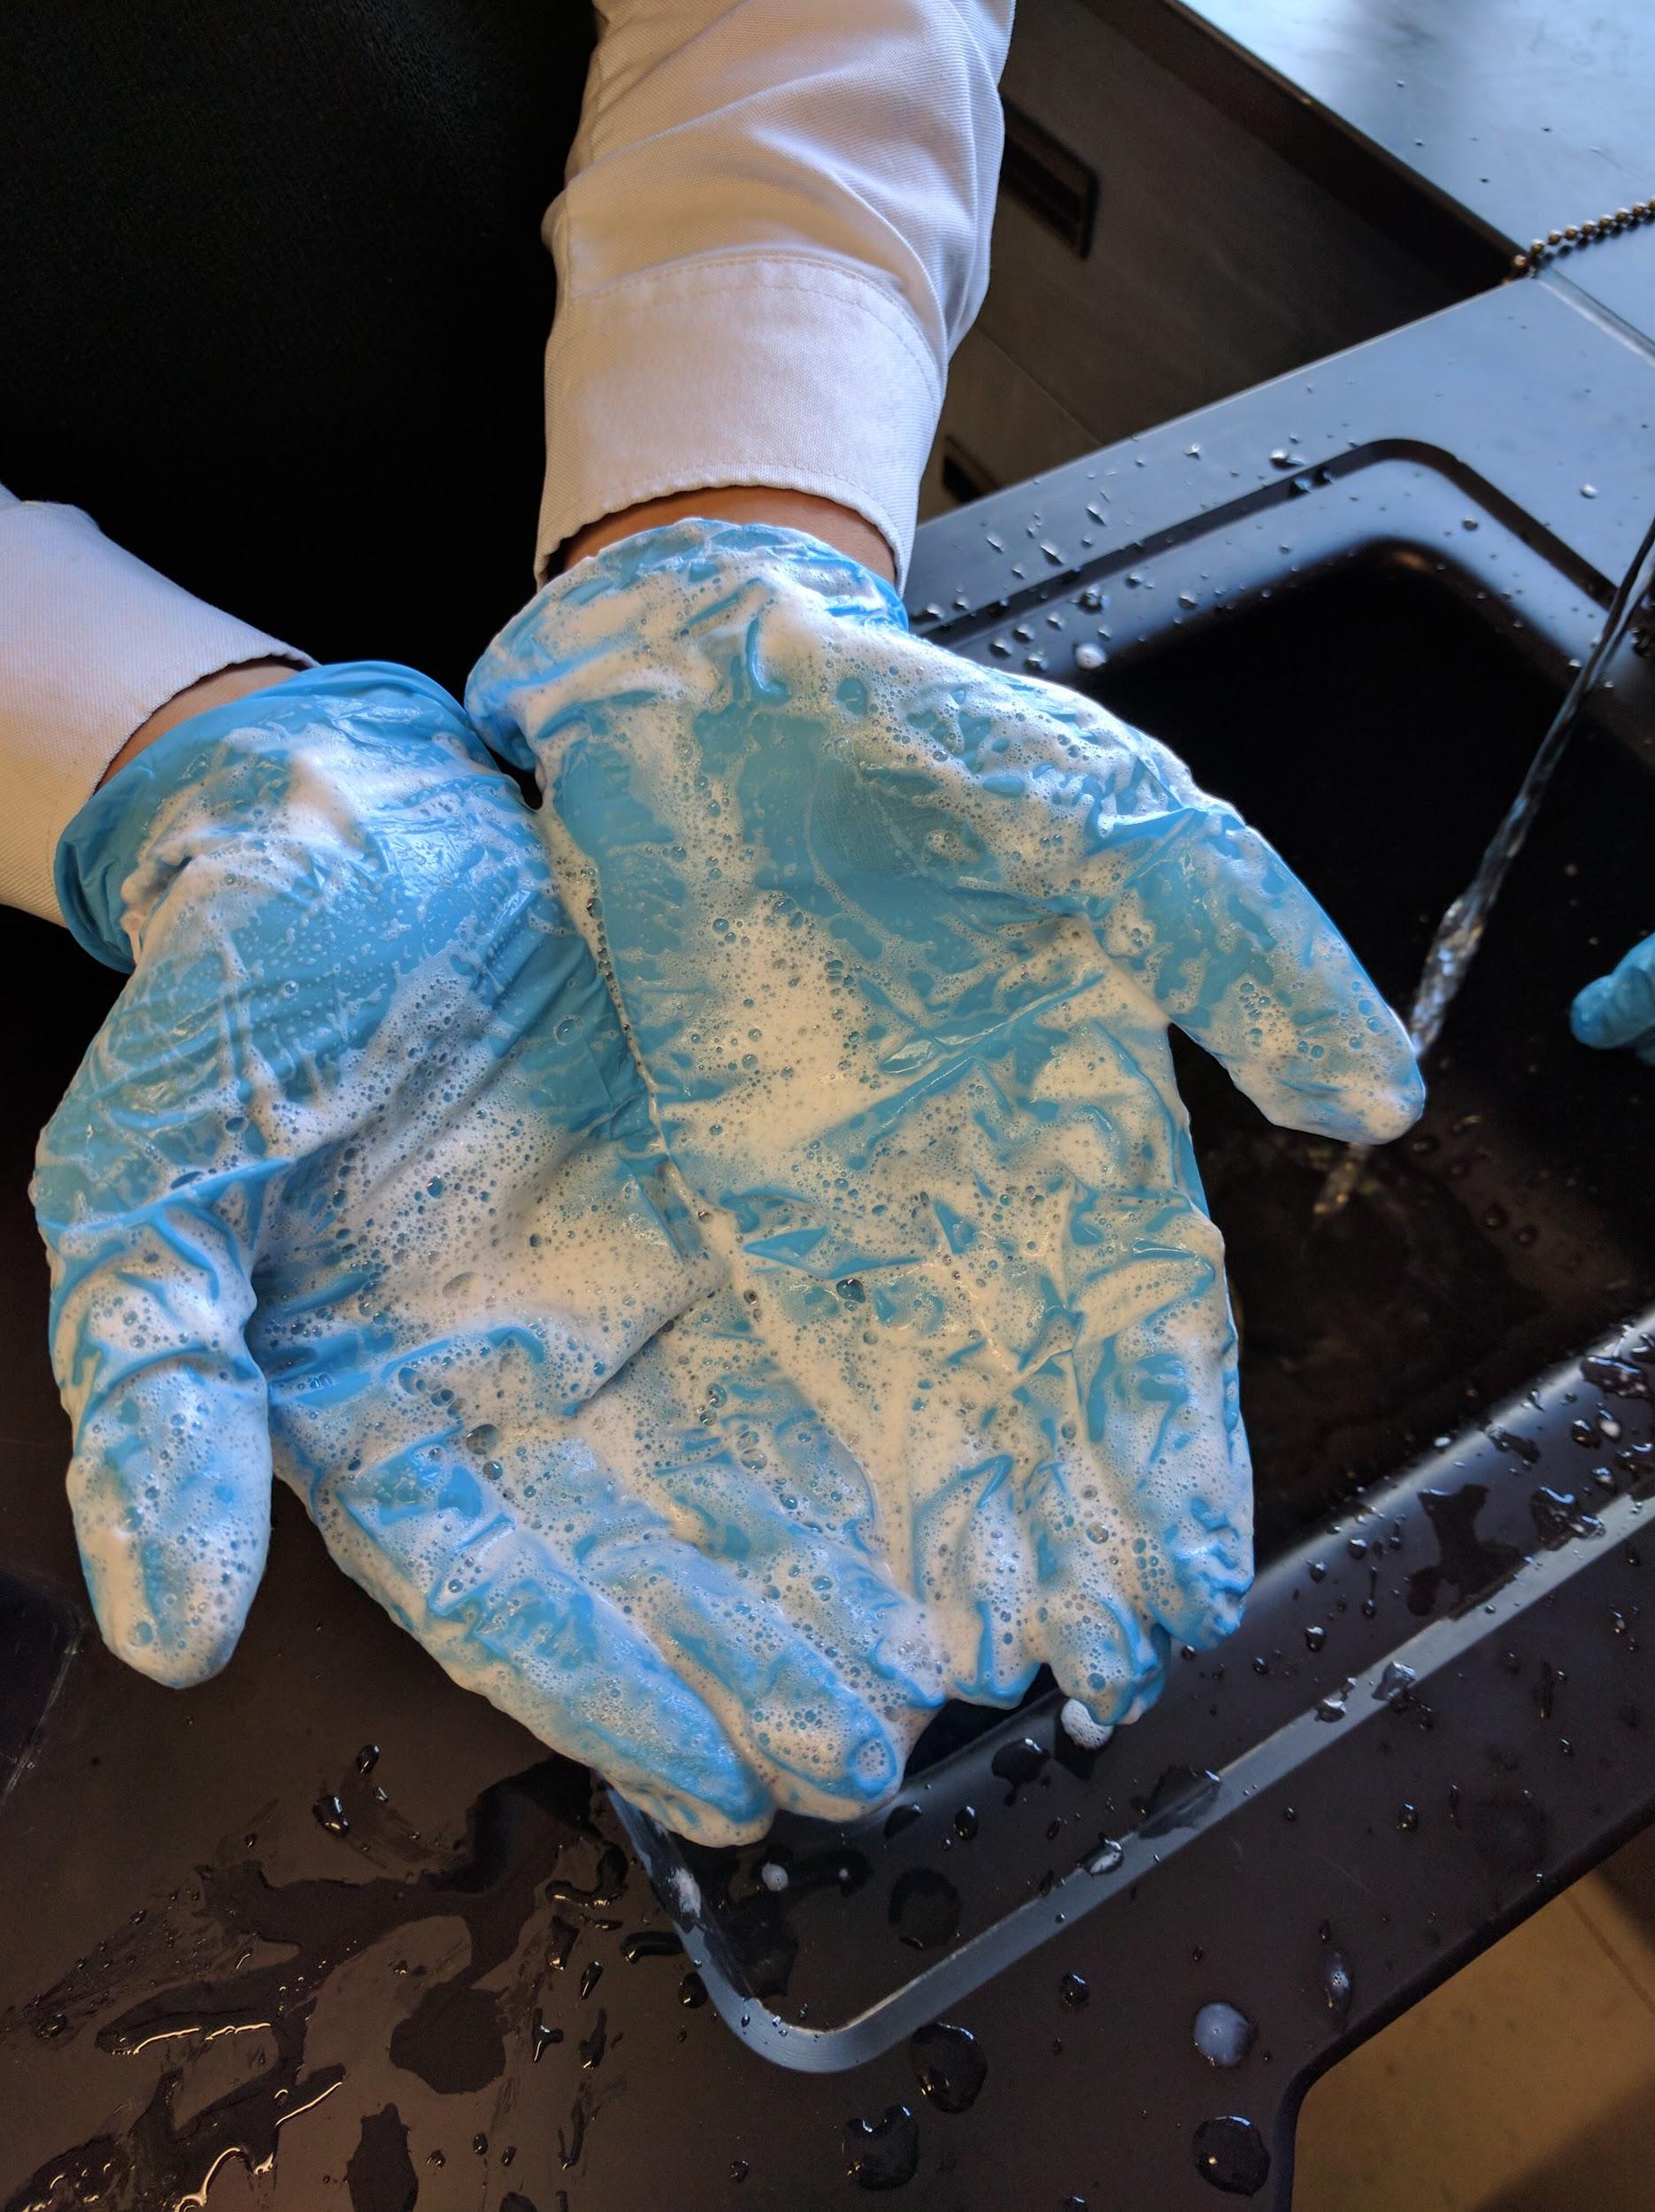
Figure 1: Figure 2:
When we placed the beaker onto the hot plate again and started stirring it for step 8, we saw a colour change in the mixture as well as a slight change in consistency. This became more apparent when the mixture was left overnight to settle, as the once very liquid mixture began to condense into a pudding like consistency. In step 12, when we added the vinegar we saw a precipitate form in the beaker. Once the precipitate was drained of all the excess liquid, the resulting product was a slightly hard/pudding like substance as shown in Figure 1. When we washed our hands with the soap, it reacted like any other soap would have reacted when coming into contact with water as shown in Figure 2.
Discussion:
- Coconut oil + Sodium Hydroxide Solution → Soap(Salt) + Glycerol
This is a saponification reaction, a reaction where a fat reacts with a base(mostly sodium hydroxide or potassium hydroxide) to form soap(salt) and glycerol.

- Adding vinegar to the soap in step 12 was to neutralize the possible remnants of the base NaOH(s) left in the mixture. Vinegar is an acid, acetic acid to be precise, and acids react to neutralize a base, such as NaOH, and vice-versa. This was to try and make the soap more safe, so that it may serve the purpose of being used without damaging the user’s skin. Also while neutralizing the base, the reaction yields a salt, NaC₂H₃O₂. Using salt is a common technique in soap making to precipitate the soap from the mixture, in a process known as “salting out the soap”

3C₁₂H₂₃COO⁻Na⁺(aq) + CH₃COOH(aq) + NaOH(aq) → H₂O(l) + NaCH₂COOH(aq) + 3C₁₂H₂₃COO⁻Na⁺(s)

This reaction is known as a neutralization reaction, as the acid and base are reacting with one another to neutralizing the other.

- It is possible that other substances found in the filtrate can be the vinegar, sodium chloride (table salt) and/or sodium hydroxide.

- Esterification and saponification are both reactions involving an esters and both yield ester in the products (in saponification a sodium atom is attached to the single bonded oxygen) alcohols are involved in both reactions as well, in esterification it is a reactant and in saponification it is a product.

- The soap molecules have both the qualities of a polar and nonpolar molecule. This comes from the fact that the structure of the soap is created from the long carbon chains from the lard/fat. Simultaneously, the salt from the sodium chloride crystals and sodium hydroxide pellets are attached at the ends of the long carbon chains allowing the chain to have both a nonpolar and polar. Due to these abilities, soap can easily break the bonds between the oils/fats nonpolar carbon chains.

- The first traceable evidence of the first soap like material date back to around 2800 BC in Ancient Babylon. The soap was not primarily used for cleaning, but for making textiles. This soap was made out of fats and ashes boiled in water. The fat was most likely obtained from animals, while the ashes were from burning wood. There could have been a burning hazard when making and collecting ashes because the ashes could still be hot and burn the person collecting them. In around 1550 BC the Egyptians started to make soap using animal and vegetable oils with alkaline salts. This is the time when soap started to become more commonly used for treating skin diseases and washing. There could have been a hazard when collecting animal fats because the animal can hurt the person trying to kill the animal for fat. In the 7th century Arabic chemists were the first to add aromatic oils and lye into soap while making it. The soaps they created had a fragrance, colour and could be either a solid or liquid. In the late 18th century a discovery was found, where sodium carbonate could be made from salt. Today soap is made by mixing oils with sodium hydroxide. Sodium hydroxide is hazardous because it is corrosive, so it will damage a person’s skin if come into contact. Even though soap has been around a long time, the things used and the way to make it are still pretty similar to what they were in the past.

Conclusion:
We used coconut oil as our oil. The coconut oil was melted and mixed with the ethanol in beaker B. Then the solution of distilled water and sodium hydroxide in beaker A was added to beaker B. While stirring the mixture, the consistency began to become a bit like pudding, but not fully. After letting it settle overnight, the consistency was more pudding like. Sodium chloride and distilled water were mixed into beaker C, which was then added to beaker B. Once we added vinegar to beaker B a precipitate formed. We poured out as much liquid from the beaker as we could, then put what was left into a filter. After leaving it overnight, our soap was successfully made. Possible sources of error that we could have occurred in this lab are using too much or too little of a substance, not allowing the substances to fully mix together, and overheating our mixture.

References:
- DiGiuseppe, Maurice. Chemistry 12. Toronto: Nelson Education, 2012. Print.
- "The History of Soap - Soap Inventors and Origins." The Soap History and Origins - First Soap Makers. N.p., n.d. Web. 01 Dec. 2016.
- "How Soap Is Made?" How Soap Is Made and Soap Ingredients. N.p., n.d. Web. 01 Dec. 2016.

