Investigation 4.2.1
Three-Dimensional Shapes

Submitted by: Steven Phang, Santiago Valdes
Submitted to: Mr. Romano
Course: SCH 4UP
Submitted on: Mon. Oct. 17/2016

Purpose
To test understanding of the VSEPR theory and three dimensional structure of molecules.

Materials
Refer to page 255 in the textbook.

Procedure
Refer to page 255 in the textbook.

Observations
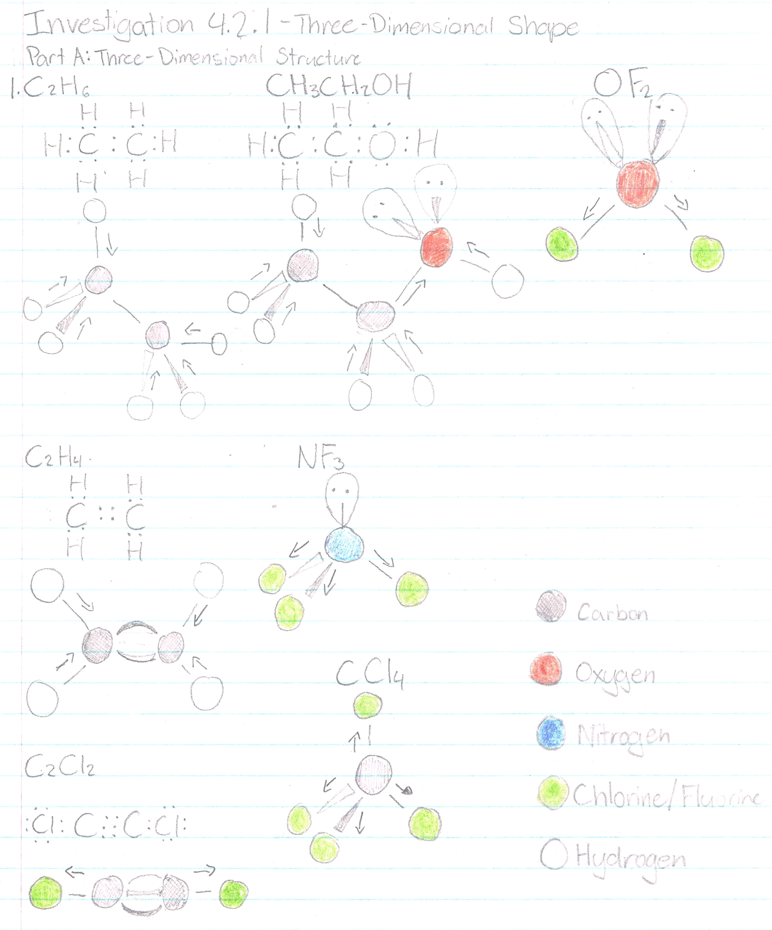

Analyze and Evaluate
- C₂H₆ - Tetrahedral
C₂H₄ - Trigonal planar
C₂Cl₂ - Linear
CH₃CH₂OH - Tetrahedral, angular
NF₃ - Pyramidal
CCl₄ - Tetrahedral
OF₂ - Angular
- OF₂, CH₃CH₂OH, NF₃, CCl₄
- OF₂, CH₃CH₂OH, NF₃, CCl₄
- It may be difficult to determine whether a molecule is polar since the shapes and the directions of the elections can be difficult to visualize.

Polarity of Molecules
Molecule Name | Shape | Bond Angle | Bonds | Molecule
C₂H₆ | Tetrahedral | 109 | Polar and nonpolar (C-C) | non-polar
C₂H₄ | Trigonal planar | 120 | Polar and nonpolar (C-C) | non-polar
C₂Cl₂ | Linear | 180 | Polar and nonpolar (C-C) | polar
CH₃CH₂OH | Tetrahedral and angular | 109 and 105 | Polar and non-polar (C-C) | polar
NF₃ | Pyramidal | 107 | polar | polar
CCl₄ | Tetrahedral | 109 | polar | non-polar
OF₂ | Angular | 105 | polar | Polar

- The predictions were correct to the polar and nonpolar molecules.

- Polarity of Molecules
Molecule Name | Shape | Bond Angle | Bond | Molecule
PH₃ | pyramidal | 109 | nonpolar | polar
CH₃OH | Tetrahedral and angular | 109 and 105 | polar | Polar
CH₃COOH | Tetrahedral, trigonal planar and angular | 109, 120 and 105 | polar | polar
BF₃ | Trigonal planar | 120 | polar | nonpolar
- The molecules that would best orientate itself through a magnetic field would be the polar molecules (CH₃OH, CH₃COOH, PH₃). They have an atom which contains a higher electronegativity, pulling towards one side of the molecule. This causes one side of the atom to be negative, allowing it to be attracted to the positive field.
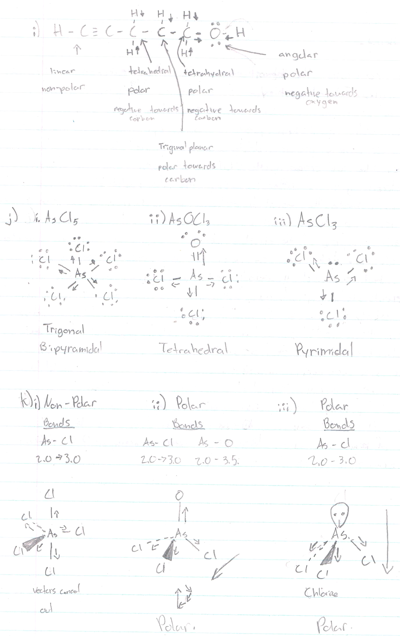

Conclusion

In conclusion, the lab illustrated the three-dimensional structures of molecules. It aided the visual understanding of how such molecules can be polar and nonpolar. The lab also gave a visual representations on the shape of the molecule’s structure and the angles created between the bonds. The lab began with drawing out the predictions of the molecules given. By using the Lewis dot diagram, the types of bonds and bond placements can easily be identified allowing for the visual transition from Lewis dot diagram to a three-dimensional structure. After the structures were predicted, physical models of the structure were created using a modelling kit and predictions were used as guidelines. After these structure have been properly constructed, the molecule polarity was predicted. This was done by finding the elements’ electronegativities and finding out whether one molecule had a stronger electronegativity than the other. Once this was completed the “vectors” of the polarity were connected to see whether or not there would be a significant final vector indicating that the molecule was polar. Molecules with asymmetric shapes were generally polar whereas symmetrical shapes were generally non-polar. A possible source of error in this lab is that a piece in the modeling kit may have been incorrectly colour coded changing the number of bonds that element could have made. When constructing the molecules three-dimensional structure one would have used an incorrect piece leading to inaccurate polarity and three-dimensional structure. Another possible error would be an incorrect Lewis dot diagram. This may have caused a mistake in the shape and amount of bonds in a three - dimensional structure, causing the diagram and the model to be incorrect.

